Chapter 18, Solution 39.

Given the circuit in Fig. 18.41, with its excitation, determine the Fourier transform of i(t).
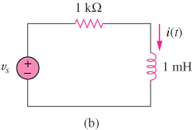
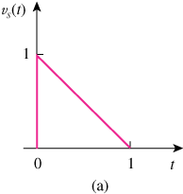

Figure 18.41
For Prob. 18.39.

Solution

